**SCREENSHOTS**

 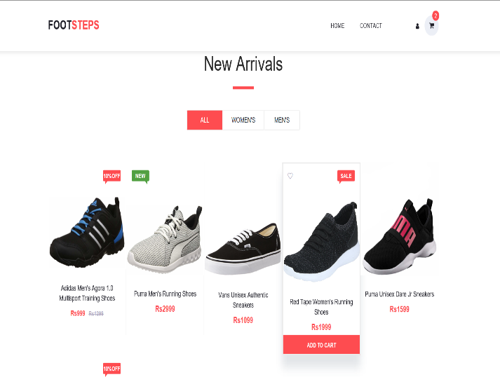

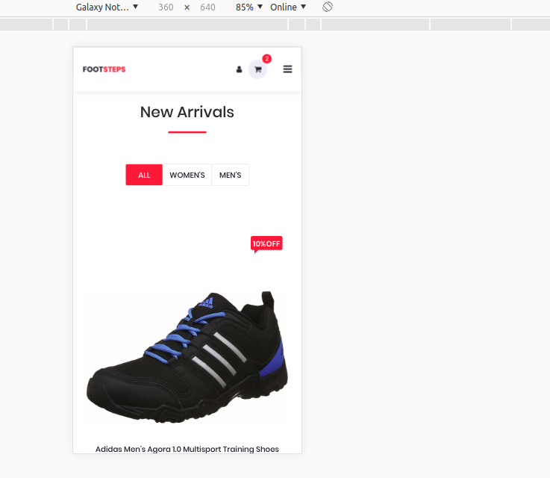 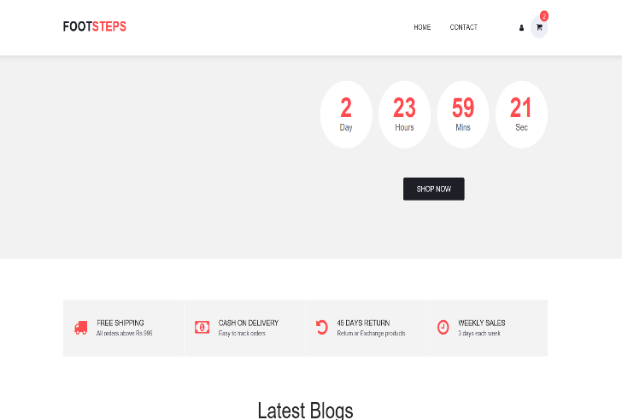

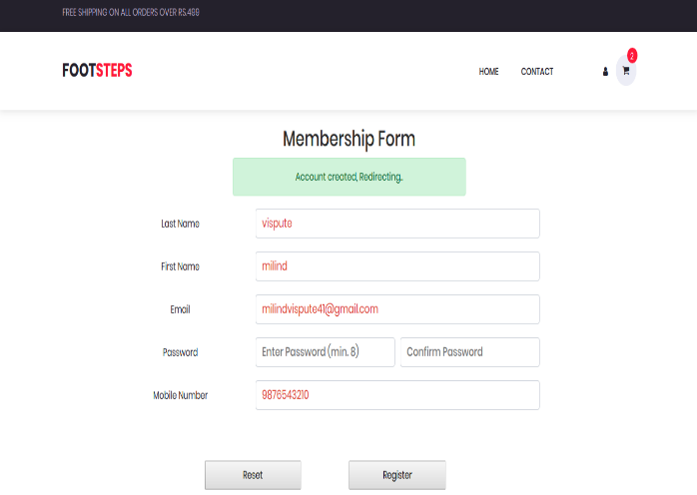 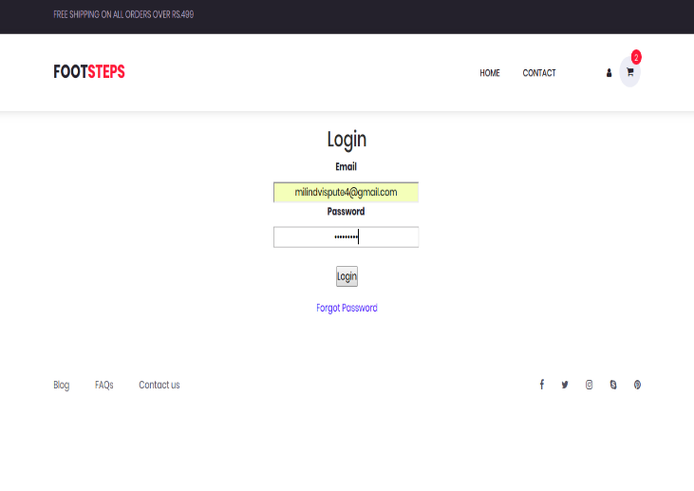

 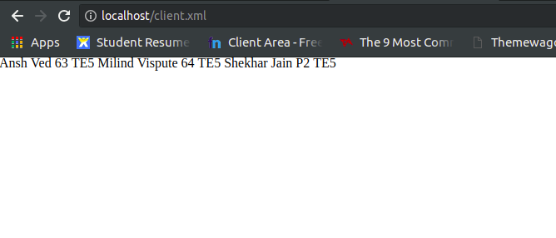

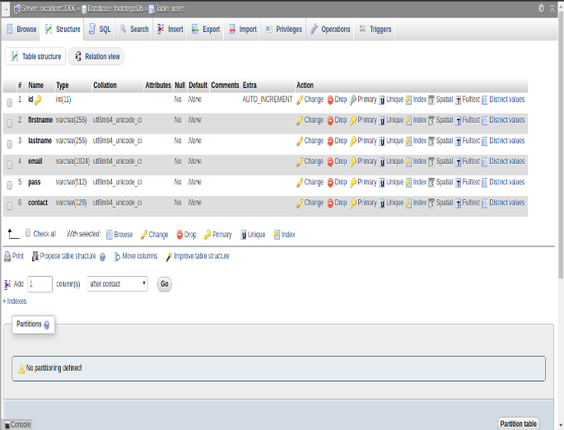 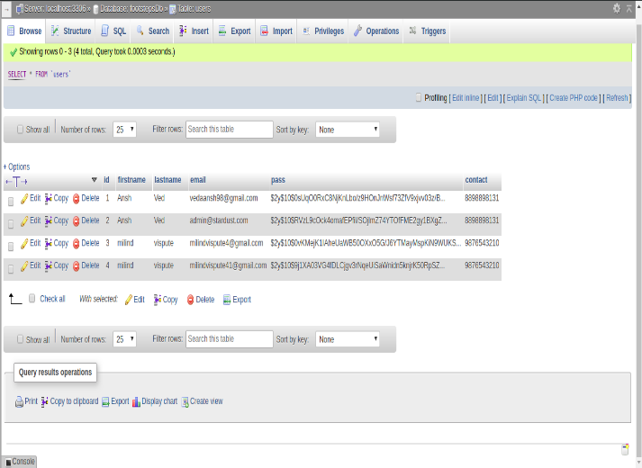

XML

XML stands for Extensible Markup Language and is a text-based markup language derived from Standard Generalized Markup Language (SGML). This tutorial will teach you the basics of XML. The tutorial is divided into sections such as XML Basics, Advanced XML, and XML tools. Each of these sections contain related topics with simple and useful examples.

The Difference between XML and HTML

XML and HTML were designed with different goals:

* XML was designed to carry data - with focus on what data is
* HTML was designed to display data - with focus on how data looks
* XML tags are not predefined like HTML tags are

**Code:**

<?xml-stylesheet href="client.xsl"?>

<studentdetails>

<student>

<name>Ansh Ved</name>

<roll>63</roll>

<class>TE5</class>

</student>

<student>

<name>Milind Vispute</name>

<roll>64</roll>

<class>TE5</class>

</student>

<student>

<name>Shekhar Jain</name>

<roll>P2</roll>

<class>TE5</class>

</student>

</studentdetails>